AI-Powered Smart Exhibition Management System with Agentic Event Assistant

A Mini Project Report Submitted in the partial fulfillment of the requirements for the award of the degree of

BACHELOR OF TECHNOLOGY

In
DEPARTMENT OF COMPUTER SCIENCE ENGINNERING
By
G.V.S Hasini-2420030735(Team Lead)
G.Hemalatha – 2420030703

Under the Esteemed Guidance of

Dr.Neelima Gogineni





K L (Deemed to be) University
DEPARTMENT OF COMPUTER SCIENCE ENGINEERING

DECLARATION

The Mini Project Report entitled “AI-Powered Smart Exhibition Management System with Agentic Event Assistant“ is a record of Bonafide work of G.V.S Hasini-2420030735,G.Hemalatha –2420030703 submitted in partial fulfillment for the award of B. Tech in Computer Science and Engineering (or) Computer Science and Information Technology to the K L University. The results embodied in this report have not been copied from any other departments/University/Institute.

G.V.S Hasini-2420030735
G.Hemalatha – 2420030703

K L (Deemed to be) University
DEPARTMENT OF COMPUTER SCIENCE ENGINEERING
CERTIFICATE

This is certify that the mini project based report entitled “AI-Powered Smart Exhibition Management System with Agentic Event Assistant” is a bonafide work done and submitted G.V.S Hasini-2420030735, G.Hemalatha – 2420030703 in partial fulfillment of the requirements for the award of the degree of BACHELOR OF TECHNOLOGY in Department of Computer Science Engineering, K L (Deemed to be University), during the academic year 2026-2027.

Signature of the Course Co-ordinator Signature of HOD

ACKNOWLEDGEMENT

The success in this project would not have been possible but for the timely help and guidance rendered by many people. Our wish to express my sincere thanks to all those who has assisted us in one way or the other for the completion of my project.

Our greatest appreciation to my guide, Dr.Neelima Gogineni, Department of Computer Science which cannot be expressed in words for his/her tremendous support, encouragement and guidance for this project.

We express our gratitude to Dr. P.Venkateshwar Sir (CSE)/Dr. Kaja Shareef Sir (CSIT), Head of the Department for Computer Science Engineering for providing us with adequate facilities, ways and means by which we are able to complete this project-based Lab.

We thank all the members of teaching and non-teaching staff members, and also who have assisted me directly or indirectly for successful completion of this project. Finally, I sincerely thank my parents, friends and classmates for their kind help and cooperation during my work.

G.V.S Hasini-2420030735
G.Hemalatha – 2420030703

TABLE OF CONTENTS

S.No. | Contents | Page no.
1. | Abstract
2. | Introduction
3. | Literature survey
4. | Problem Statement and Objectives
5. | Hardware and Software requirements
6. | Implementation
7. | Results & Discussion
8. | Conclusion & Future Scope
9. | References

- ABSTRACT

The AI-Powered Smart Exhibition Management System with Agentic Event Assistant is proposed to address the limitations of traditional exhibition management systems, which rely heavily on manual processes for visitor registration, stall management, scheduling, navigation, communication, and feedback collection. The proposed system integrates Artificial Intelligence, Retrieval-Augmented Generation (RAG), Large Language Models (LLMs), and Agentic AI to provide an intelligent and interactive exhibition experience. The Agentic Event Assistant understands visitor requirements, answers queries, recommends relevant stalls, products, sessions, and events, assists with event scheduling, and provides smart navigation and real-time guidance. The system also supports exhibitors and organizers by monitoring visitor engagement, analyzing feedback and preferences, and generating useful AI-based insights. By combining personalized recommendations, intelligent assistance, event management, and autonomous agent capabilities into a single platform, the proposed system aims to reduce the workload of organizers while improving the experience of visitors and exhibitors. The system provides a smart, personalized, efficient, and user-friendly solution for modern exhibition management.

Team Members:
G.V.S Hasini-2420030735[8790679068]
G.Hemalatha – 2420030703[9398511596]

2.INTRODUCTION

The AI-Powered Smart Exhibition Management System with Agentic Event Assistant is designed to make exhibition and event management smarter, easier, and more efficient using Artificial Intelligence. Traditional exhibition management systems depend on manual processes for visitor registration, stall management, event scheduling, navigation, and communication. These processes can be time-consuming and may create difficulties for both visitors and organizers.
To overcome these challenges, the proposed system integrates AI and agentic capabilities to provide intelligent and personalized assistance. The AI-powered event assistant helps visitors find relevant stalls, explore products, receive event information, plan their schedules, and get answers to their queries. It also supports organizers in managing exhibition activities, monitoring visitor engagement, and analyzing feedback.
The main aim of this project is to reduce manual workload, improve coordination between visitors, exhibitors, and organizers, and provide a personalized and interactive exhibition experience. By combining AI-based recommendations, smart navigation, schedule management, and intelligent insights, the system aims to create a more organized, user-friendly, and efficient exhibition environment.

3.LITERATURE SURVEY

1. Whova – Event Management Platform
Whova is an event management platform that helps organizers manage registrations, agendas, speakers, and attendee communication. It provides mobile event applications, personalized schedules, notifications, attendee networking, and exhibitor information. Visitors can explore event sessions, connect with other participants, and interact with exhibitors. This project is similar to our proposed system because it combines event management, visitor engagement, and exhibitor support in one platform. However, our project aims to emphasize an agentic AI assistant for personalized guidance.

2. Swapcard – AI-Powered Event Platform
Swapcard is an event platform designed for exhibitions, trade shows, and conferences. It uses AI to recommend relevant exhibitors, products, sessions, and people based on attendee profiles and interests. It also supports networking, meeting scheduling, exhibitor management, and engagement analytics. This project is closely related to our system because it uses AI to improve visitor experiences and connect attendees with suitable exhibitors. Our proposed system aims to combine similar features with an agentic assistant that can guide users through different event activities.

3. Cvent – Event Management and Mobile Event Apps
Cvent provides event management solutions for planning and conducting conferences, exhibitions, and other professional events. Its features include attendee registration, event schedules, mobile event applications, exhibitor engagement, and event analytics. Its mobile event platform also highlights personalized attendee experiences and AI-based recommendations. This project is relevant to our proposed system because it helps organizers manage event activities and enables visitors to access important information. Our system aims to add an agentic assistant that can provide more interactive and personalized support.

4. Zoho Backstage – Event Management System
Zoho Backstage is an event management platform that supports event websites, registration, session scheduling, attendee engagement, and exhibitor management. Its AI-powered networking features recommend relevant connections based on attendee interests, roles, and event activity. The platform also offers an AI event chatbot that answers questions about agendas, speakers, sessions, and venue details. This project is similar to our proposed system because it combines event organization with AI-based assistance. Our system further aims to integrate personalized stall recommendations and intelligent visitor guidance.

5. Amego – AI-Powered Event Companion
Amego provides an event platform with mobile applications, personalized agendas, attendee networking, sponsor tools, and analytics. Its Sidekick AI feature helps attendees discover relevant sessions, build schedules, find networking opportunities, and receive event-specific recommendations. The platform uses event information and attendee context to provide more relevant assistance. This is closely related to our proposed system because both aim to improve the visitor experience using AI. Our project focuses specifically on combining these capabilities with exhibition management and an agentic event assistant.

6. Eventdex – AI-Powered Event Management
Eventdex offers event management solutions with features such as registration, business matchmaking, attendee engagement, and event analytics. Its AI capabilities include an intelligent chatbot, recommendations for sessions and exhibitors, and matching attendees with relevant business contacts. These features help organizers coordinate events and enable participants to discover useful networking opportunities. This project relates to our proposed system because it uses AI to simplify event activities and improve communication. Our system aims to extend this approach with smart exhibition navigation and personalized event planning.

7. Map Your Show – Exhibition and Trade Show Planner
Map Your Show provides digital tools that help visitors plan their participation in exhibitions and trade shows. Its connected event planner allows attendees to explore exhibitors, products, events, and contacts according to their interests. It also provides floor-plan integration and an AI assistant called Ask Lina, which helps visitors discover exhibitors and sessions and obtain event-specific information. This project is highly relevant to our system because it combines exhibition planning, intelligent recommendations, and navigation. Our proposed system aims to bring these features together with additional organizer support and agentic task assistance.

8. ExpoFP – Interactive Exhibition Floor Plans
ExpoFP provides interactive floor plans for exhibitions, conferences, and trade shows. Visitors can search for companies, booths, and categories, while the platform highlights matching locations on the map. It also supports digital wayfinding, exhibitor lists, session schedules, and navigation across buildings or floors. This project is relevant to our proposed system because it addresses the challenge of helping visitors locate specific exhibition stalls and facilities. Our system aims to combine similar navigation capabilities with AI-based recommendations and a conversational event assistant.

9. EventHex – AI-Powered Event Management Platform
EventHex is an event management platform that integrates AI features into event planning and attendee engagement. It provides tools for event websites, session management, networking, event analytics, and AI-generated session summaries. Its AI assistant, EventHex Copilot, helps users obtain event information and perform management-related tasks, while its networking feature recommends relevant connections. This project is similar to our proposed system because it combines event operations with AI-driven assistance. Our system focuses more specifically on exhibition stall discovery, visitor navigation, and coordination between visitors and exhibitors.

10. Certain Event Advisor – Personalized Attendee Experience
Certain's Event Advisor uses AI to personalize attendee journeys by recommending relevant sessions, exhibits, and networking opportunities. It considers attendee profiles, goals, interests, and event behavior to help users plan their participation. The platform also supports personalized scheduling and provides recommendations through event apps, websites, and emails. This project is related to our proposed system because it focuses on intelligent recommendations and personalized event experiences. Our system aims to combine these features with exhibition management functions and an agentic assistant that supports visitors and organizers throughout the event.

4.Problem Statement and Objectives

Problem Statement:
Traditional exhibition management systems lack integrated AI-based assistance, personalized recommendations, and smart navigation for visitors and organizers.
Problem Description:
Manual exhibition management makes registration, stall coordination, scheduling, and visitor support time-consuming and inefficient. Visitors also face difficulties finding relevant stalls, sessions, and facilities.
Objectives:
- Automate Exhibition Management: Reduce manual work in registration, stall management, scheduling, and feedback collection.
- Develop an AI-Based Event Assistant: Provide instant responses to visitor queries.
- Provide Personalized Recommendations: Suggest relevant stalls, products, and sessions based on visitor interests.
- Enable Smart Navigation: Help visitors locate stalls, sessions, and facilities easily.
- Manage Event Schedules: Help visitors plan activities and receive reminders.
- Support Organizers and Exhibitors: Improve coordination and monitor visitor engagement.
- Generate AI-Based Insights: Analyze visitor preferences and feedback to improve future exhibitions.

5.HARDWARE AND SOFTWARE REQUIREMENTS

Hardware Requirements:
- Processor: Intel Core i5 or equivalent.
- RAM: Minimum 8 GB.
- Storage: Minimum 256 GB HDD/SSD.

Software Requirements:
- Operating System: Windows 10/11.
- Frontend: HTML, CSS, JavaScript, React.js.
- Backend: Python (Flask/FastAPI) or Node.js.
- AI/ML Tools: Python, AI APIs, and a database such as MySQL

6.IMPLEMENTATION
import { BrowserRouter, Routes, Route, Navigate } from "react-router-dom";
import Events from "./pages/Events";
import Navbar from "./components/Navbar";
import Home from "./pages/Home";
import Exhibitions from "./pages/Exhibitions";
import ExhibitionDetails from "./pages/ExhibitionDetails";
import Stalls from "./pages/Stalls";
import StallDetails from "./pages/StallDetails";
import Exhibitors from "./pages/Exhibitors";
import ExhibitorDetails from "./pages/ExhibitorDetails";
import Login from "./pages/Login";
import Register from "./pages/Register";
import VisitorDashboard from "./pages/VisitorDashboard";
import OrganizerDashboard from "./pages/OrganizerDashboard";
import ExhibitorDashboard from "./pages/ExhibitorDashboard";
import AIAssistant from "./pages/AIAssistant";
function App() {
return (
<BrowserRouter>
<Navbar />
<Routes>
<Route
path="/"
element={<Navigate to="/login" replace />}
/>
<Route
path="/login"
element={<Login />}
/>
<Route
path="/register"
element={<Register />}
/>
<Route
path="/home"
element={<Home />}
/>
<Route
path="/exhibitions"
element={<Exhibitions />}
/>
<Route
path="/exhibitions/:id"
element={<ExhibitionDetails />}
/>
<Route
path="/events"
element={<Events />}
/>
<Route
path="/stalls"
element={<Stalls />}
/>
<Route
path="/stalls/:id"
element={<StallDetails />}
/>
<Route
path="/exhibitors"
element={<Exhibitors />}
/>
<Route
path="/exhibitors/:id"
element={<ExhibitorDetails />}
/>
<Route
path="/visitor-dashboard"
element={<VisitorDashboard />}
/>
<Route
path="/organizer-dashboard"
element={<OrganizerDashboard />}
/>
<Route
path="/exhibitor-dashboard"
element={<ExhibitorDashboard />}
/>
<Route
path="/assistant"
element={<AIAssistant />}
/>
</Routes>
</BrowserRouter>
);
}
export default App;

7.RESULTS & DISCUSSION

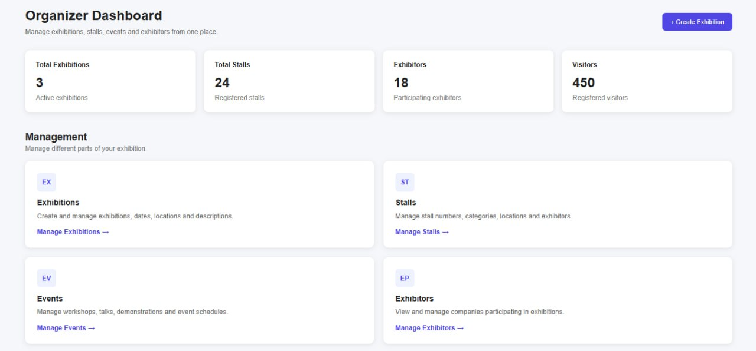

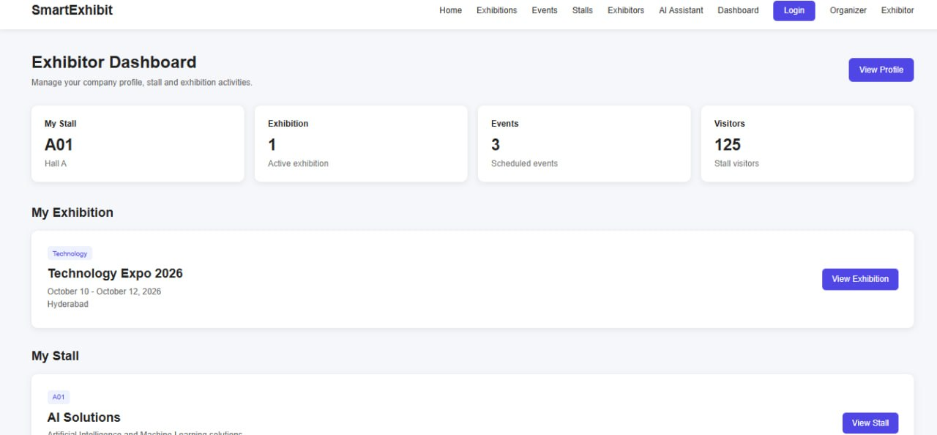

8.CONCLUSION & FUTURE SCOPE

8.1 Conclusion
The AI-Powered Smart Exhibition Management System with Agentic Event Assistant aims to improve traditional exhibition management by integrating Artificial Intelligence and automation. The system helps simplify visitor registration, stall management, event scheduling, and communication. It provides intelligent assistance by answering visitor queries, recommending relevant stalls and sessions, and helping visitors plan their activities. It also supports organizers in managing exhibition activities and analyzing visitor feedback. Overall, the proposed system aims to reduce manual effort, improve coordination, and provide a more personalized, interactive, and efficient exhibition experience.

8.2 Future Scope
The system can be enhanced in the future by introducing the following features:
- Advanced AI Assistant: Improve the assistant's ability to understand queries and provide accurate, personalized responses.
- Smart Navigation: Add interactive maps and real-time indoor navigation to help visitors locate stalls and facilities.
- Multilingual Support: Enable communication in multiple languages for visitors from different regions.
- Automated Notifications: Send reminders about upcoming sessions, schedules, and important event announcements.
- Visitor Analytics: Analyze visitor interests, stall popularity, and feedback to help organizers make better decisions.
- Advanced Agentic AI: Enable AI agents to assist with scheduling, event coordination, and other management tasks with minimal human intervention.
These future enhancements can make the system more intelligent, scalable, and user-friendly, helping organizers conduct exhibitions more effectively while providing visitors with a smooth and engaging experience.

9.REFERENCES

1.Whova – Event Management Platform: https://whova.com/
2. Swapcard – AI-Powered Event Platform: https://www.swapcard.com/
3. Cvent – Event Management Solutions: https://www.cvent.com/en/event-marketing-management/mobile-event-apps
4. Zoho Backstage – Event Management System: https://www.zoho.com/backstage/
5. Amego – AI-Powered Event Platform: https://www.amego.com/
6. Eventdex – Event Management Platform: https://www.eventdex.com/
7. Map Your Show – Exhibition Planning Platform: https://www.mapyourshow.com/map-your-show-mys-connected
8. ExpoFP – Interactive Exhibition Floor Plans: https://expofp.com/
9. EventHex – AI-Powered Event Management: https://eventhex.ai/
10. Certain Event Advisor – AI-Powered Event Personalization: https://certain.com/event-advisor/

